**Las mejores películas de terror del 2012!**

**VHS** (USA) Adam Wingard, Glenn McQuaid, Radio Silence, David Bruckner, Joe Swanberg, Ti West

[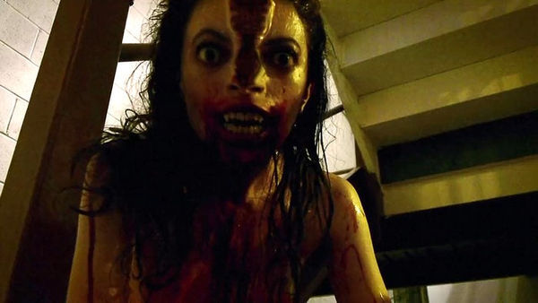](http://www.bloghorror.com/2012/08/vhs-2012.html)

**THE COLLECTION** (USA) Marcus Dunstan

[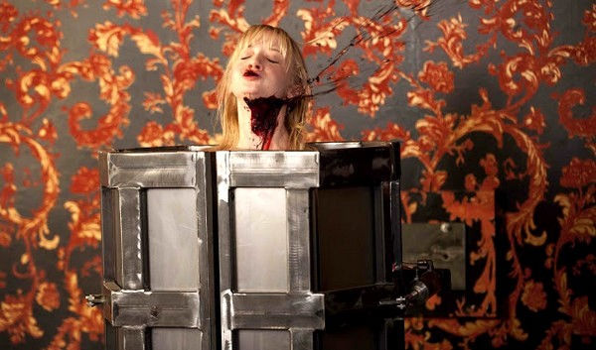](http://www.bloghorror.com/2013/01/the-collection-2012.html)

**EXIT HUMANITY** (Canada) John Geddes

[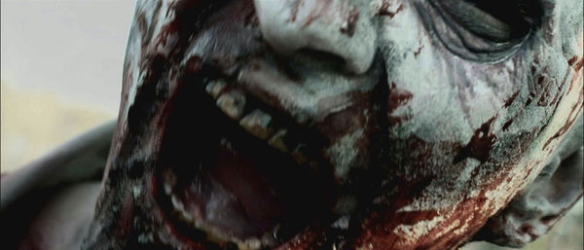](http://www.bloghorror.com/2012/05/exit-humanity-2012.html)

**THE INNKEEPERS** (USA) Ti West

[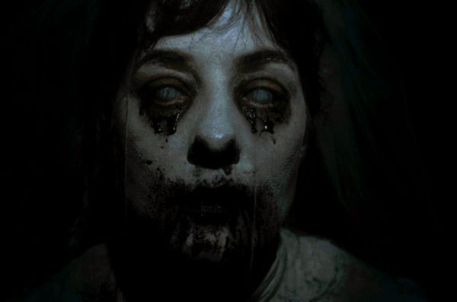](http://www.bloghorror.com/2012/01/innkeepers-2012.html)

**THE POSSESSION** (USA) Ole Bornedal

[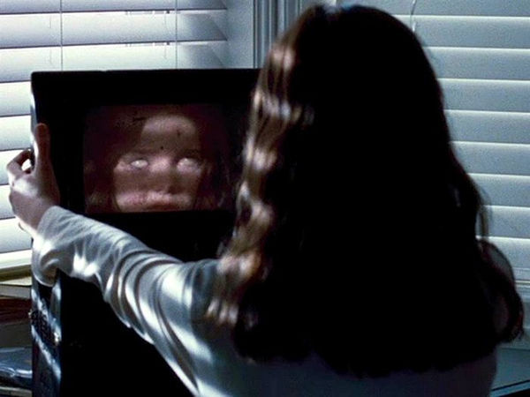](http://www.bloghorror.com/2012/08/the-possession-2012.html)

**THE GREY** (USA) Joe Carnaha[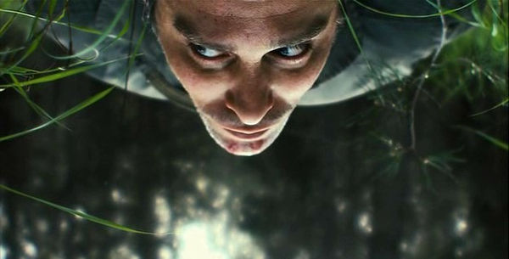](http://www.bloghorror.com/2012/07/rabies-2010.html)

**LA CARA OCULTA** (Colombia) Andrés Baiz

[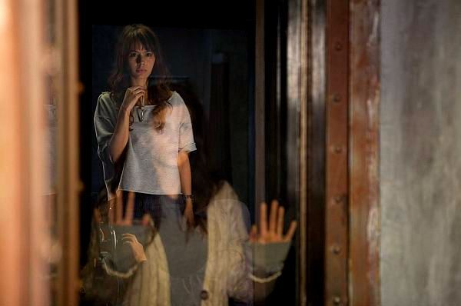](http://www.bloghorror.com/2012/04/la-cara-oculta-2012.html)

**THE WOMAN IN BLACK** (USA) James Watkins

[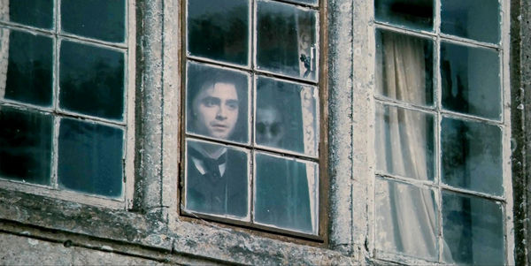](http://www.bloghorror.com/2012/02/woman-in-black-2012.html)

**MARTHA MARCY MAY MARLENE** (USA) Sean Durkin

[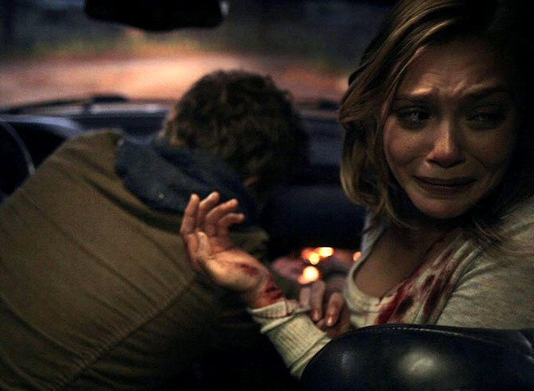](http://www.bloghorror.com/2012/05/martha-marcy-may-marlene-2011.html)

**RESIDENT EVIL: DAMNATION** (Japon) Makoto Kamiya

[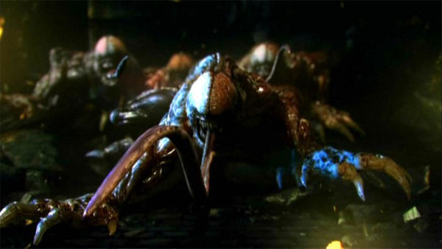](http://www.bloghorror.com/2012/09/residen-evil-damnation.html)

**THE DIVIDE** (Alemania, USA, Canada) Xavier Gens

[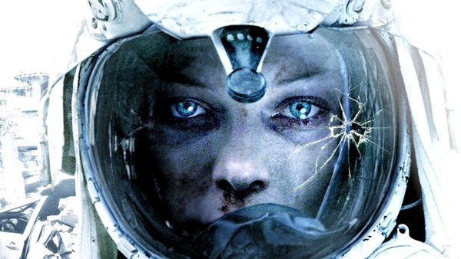](http://www.bloghorror.com/2012/03/divide-2011.html)

**MIENTRAS DUERMES** (España) Jaume Balaguero

[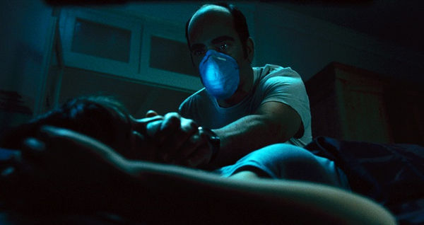](http://www.bloghorror.com/2012/02/sleep-tight-mientras-duermes-2012.html)

**SINISTER** (USA) Scott Derrickson

[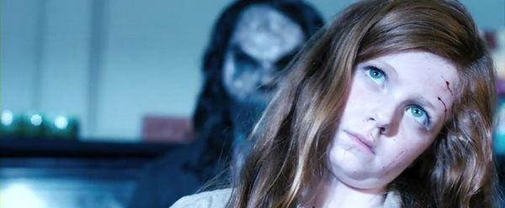](http://www.bloghorror.com/2012/06/sinister-2012.html)

**TAKE SHELTER** (USA) Jeff Nichols

[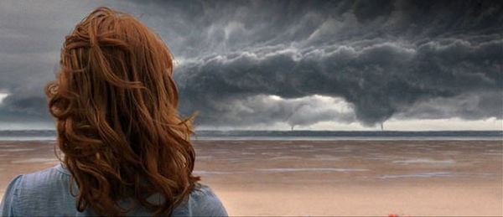](http://www.bloghorror.com/2012/02/take-shelter-2011.html)